**DAILY ONLINE ACTIVITIES SUMMARY**

|  |  |  |  |  |  |  |  |  |
| --- | --- | --- | --- | --- | --- | --- | --- | --- |
| **Date:** | 11-06-2020 | | | | | **Name:** | D Richard Franklin | |
| **Sem & Sec** | Fourth sem section A | | | | | **USN:** | 4AL18CS020 | |
| **Online Test Summary** | | | | | | | | |
| **Subject** | | N/A | | | | | | |
| **Max. Marks** | | N/A | | **Score** | | | N/A | |
| **Certification Course Summary** | | | | | | | | |
| **Course** | 1. **Machine learning foundations** | | | | | | | |
| **Certificate Provider** | | | greatlearning | | **Duration** | | | 3 hr |
| **Coding Challenges** | | | | | | | | |
| **Problem Statement:**  1: [Write a Java Program to Segregate Even and Odd numbers](https://github.com/orgs/alvas-education-foundation/teams/2nd-year/discussions/114)  2: write a program to print the sum of boundary elements of a matrix | | | | | | | | |
| **Status:** completed | | | | | | | | |
| **Uploaded the report in Github** | | | | | yes | | | |
| **If yes Repository name** | | | | | <https://github.com/alvas-education-foundation/Richard_Franklin> | | | |
| **Uploaded the report in slack** | | | | | yes | | | |

**Online Test Details: N/A**

**Online Course Details:**

1. Name of course: **Machine learning foundations**

Certificate provider: greatlearning

The total course was about the basics and the necessary prerequisites for machine learning. I went through few sections of the course which was about few mathematical concepts which is needed for machine learning.

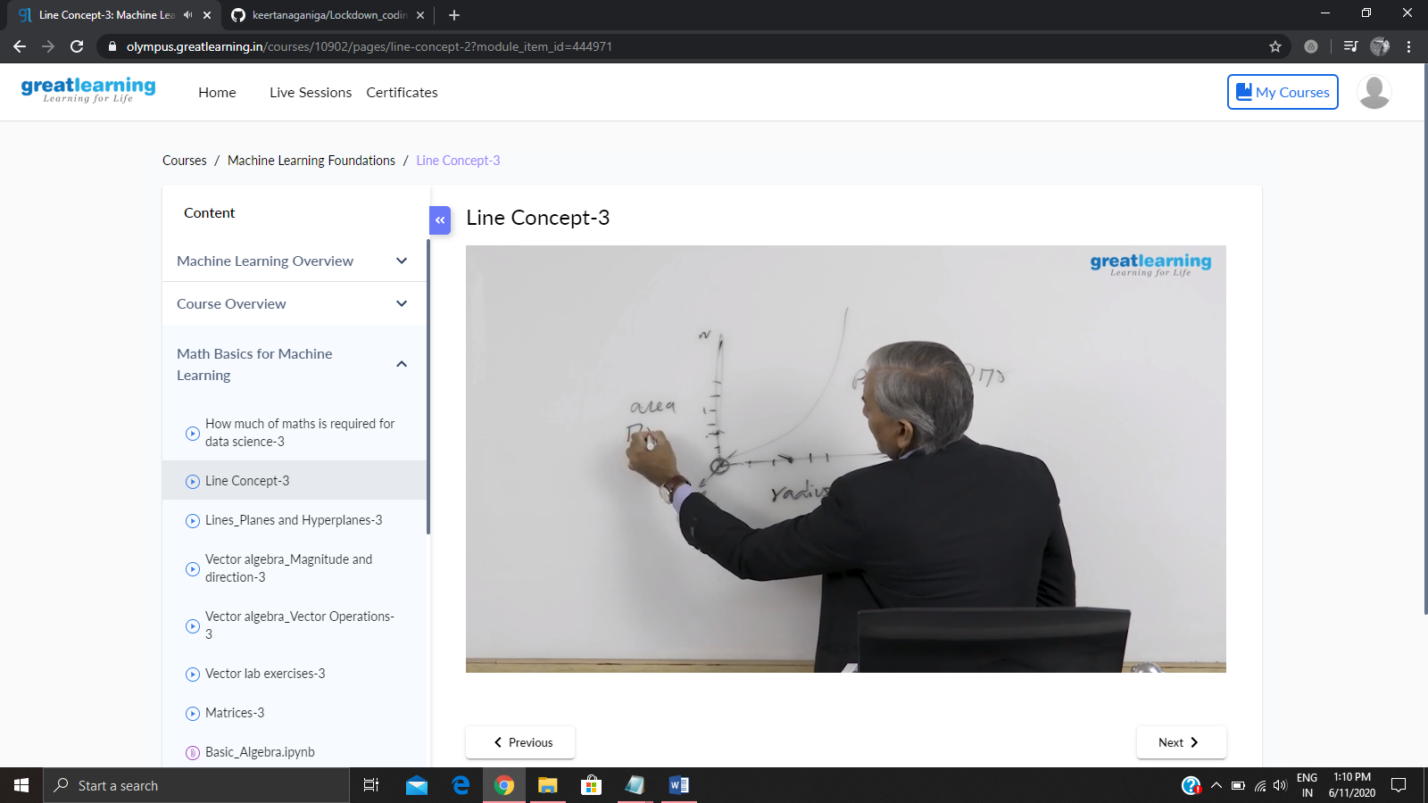

**Online coding:**

Problem 1: (using java) [Write a Java Program to Segregate Even and Odd numbers](https://github.com/orgs/alvas-education-foundation/teams/2nd-year/discussions/114)

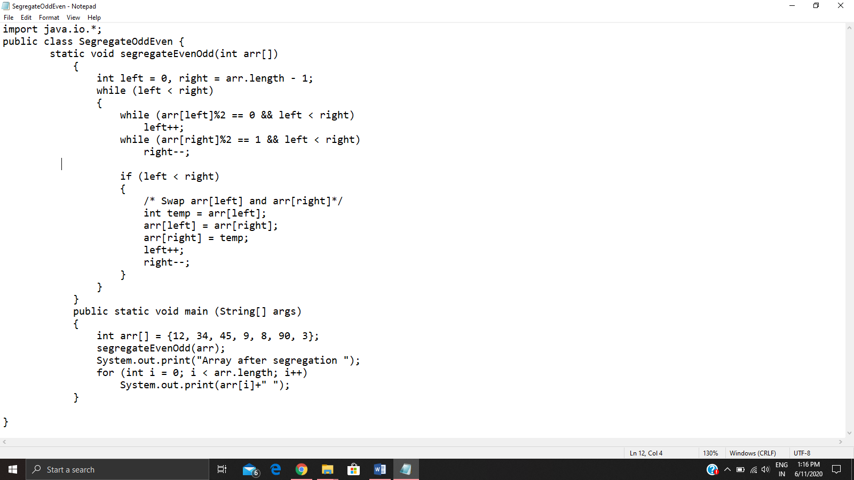

Problem 2: (using C language) write a program to print the sum of boundary elements of a matrix

